**How to install and Configure Jenkins on Linux**

**Step:1 Add Jenkins Repository**

[root@jenkins ~]# wget -O /etc/yum.repos.d/jenkins.repo http://pkg.jenkins.io/redhat-stable/jenkins.repo

[root@jenkins ~]# rpm --import http://pkg.jenkins.io/redhat-stable/jenkins.io.key

**Step:2 Install Jenkins and Java**

Run the below command to install Jenkins and Java

[root@jenkins ~]# yum install jenkins java-1.8.0-openjdk –y

**Step:3 Start and Enable Jenkins Service**

Run the following service commands to start and enable the jenkins service

[root@jenkins ~]# service Jenkins start

[root@jenkins ~]# service Jenkins enable

**Step:4 Open the ports (80 and 8080) in OS firewall.**

In case firewall is enabled on your Linux server then run the following commands to open jenkins related ports like 80 and 8080.

root@jenkins ~]# firewall-cmd --zone=public --add-port=8080/tcp --permanent

success

[root@jenkins ~]# firewall-cmd --zone=public --add-service=http --permanent

success

[root@jenkins ~]# firewall-cmd --reload

success

[root@jenkins ~]#

**Step:5 Check security Group policy and add Jenkins port (e.g. port 8080)**

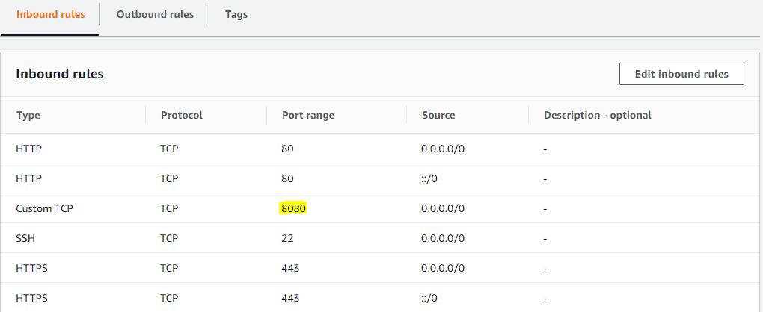

**Step:6 Access the Jenkins Web portal**

Access the URL : http://<Ip-Address-of-your-Server>:8080

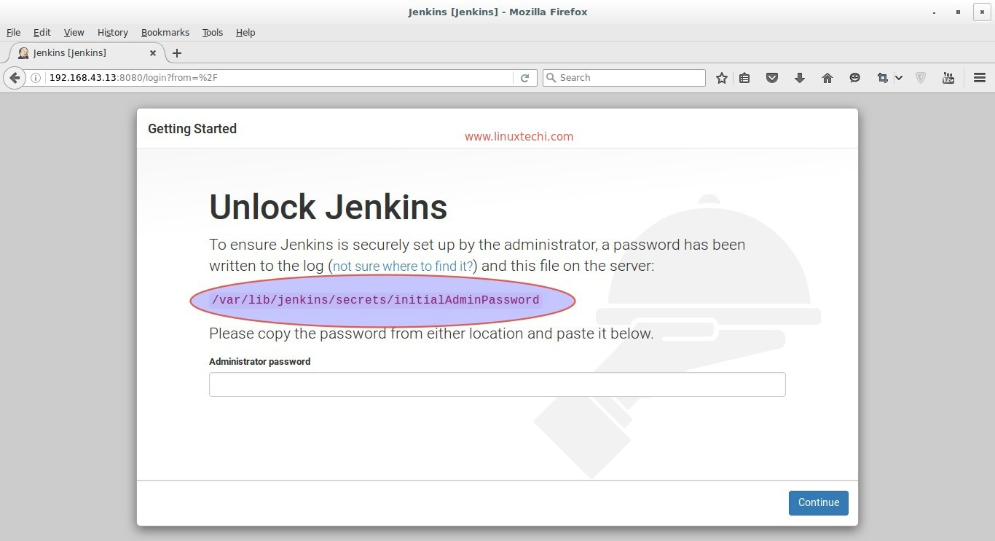

Step:7 Get the InitialAdminPassword and paste on Administrator Password section.

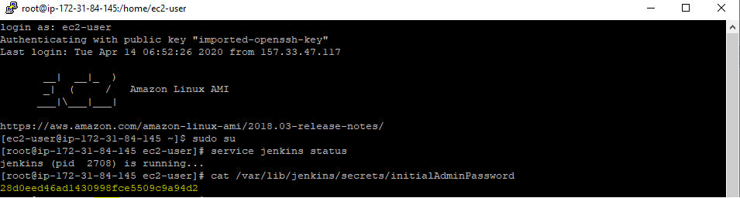

Step:8 Now you can see Jenkins home page.

